Cloud-Based Self-Healing Infrastructure Monitoring System
Architecture Document
1. Overview
The Cloud-Based Self-Healing Infrastructure Monitoring System is designed to automatically detect system failures and recover from them without manual intervention. The system ensures high availability, scalability, and reliability by leveraging cloud-native services.
The system evolved from a basic infrastructure setup in Sprint 1 into an event-driven automated monitoring and recovery system in Sprint 2 using AWS services.
2. Evolution of Architecture:
Stage | Description | Key Additions
Sprint 1 | Basic cloud infrastructure with EC2 instances, Load Balancer, Auto Scaling, and monitoring setup. Focused on deployment, traffic distribution, and system monitoring. | EC2 setup, Launch Template, ALB, Auto Scaling Group, CloudWatch monitoring
Sprint 2 | Transition to event-driven architecture with automation, logging, and visualization. Added alerting, logging, and dashboard for system insights. | SNS notifications, Lambda logging, DynamoDB, CloudWatch Dashboard

Why Event-Driven Architecture?
- System failures occur as real-time events (CPU spike, health check failure)
- CloudWatch generates alarm events
- Lambda reacts to events automatically
- Auto Scaling performs recovery without manual intervention
This approach:
- Improves system reliability
- Reduces downtime
- Enables automatic recovery
- Supports scalable cloud infrastructure

High-Level Architecture:
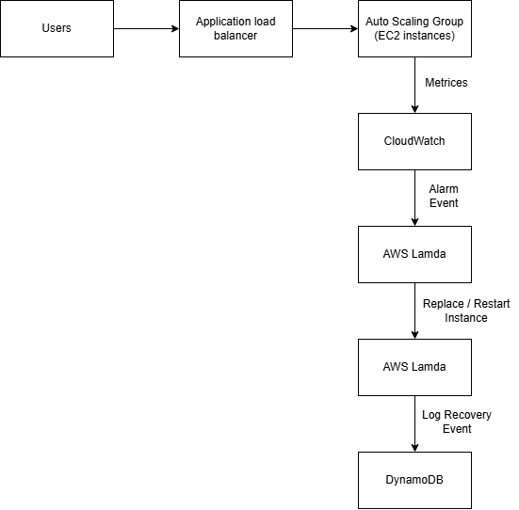
- Client: Users access the system via a web browser through the Load Balancer
- Compute Layer: EC2 instances host the application
- Scaling Layer: Auto Scaling Group manages instance lifecycle
- Monitoring Layer: CloudWatch tracks metrics and triggers alarms
- Alerting Layer: SNS sends notifications
- Automation Layer: Lambda logs events
- Storage Layer: DynamoDB stores event logs
- Visualization Layer: CloudWatch Dashboard displays system metrics
3. Use Case Diagram
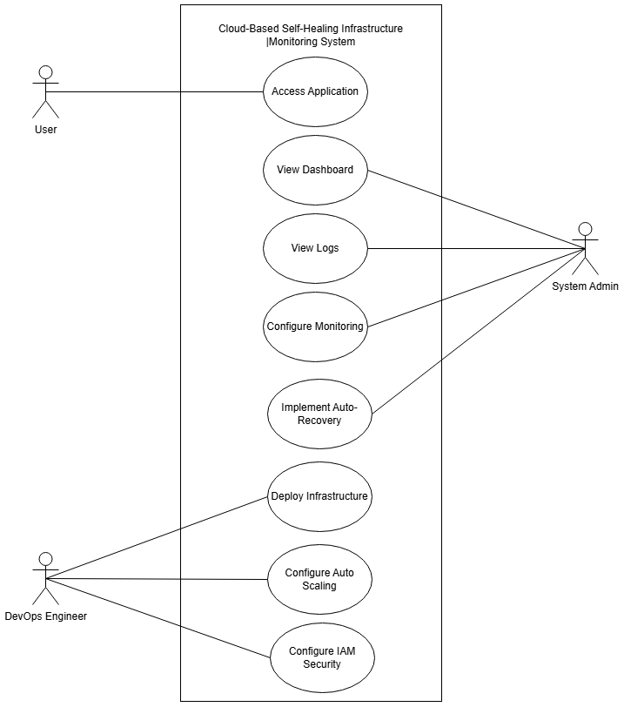
Actors:
- User
- System Administrator
- DevOps Engineer
Key Use Cases:
- Access Application
- Monitor System
- Receive Alerts
- View Dashboard
- Configure Infrastructure
4. Final System Architecture
4.1 Infrastructure Layer (Sprint 1)
- EC2 instances are launched using Launch Templates.
- Application Load Balancer distributes incoming traffic.
- Auto Scaling Group ensures minimum instance availability.
- Health checks ensure only healthy instances receive traffic.
- CloudWatch monitors CPU utilization and system metrics.
4.2 Event-Driven Automation Layer (Sprint 2)
The system implements event-driven automation using AWS services:
- CloudWatch detects anomalies (CPU spikes or failure).
- CloudWatch Alarm triggers:
  - SNS → sends notification
  - Lambda → logs event
- Lambda stores event details in DynamoDB.
- Auto Scaling Group independently handles:
  - Scaling under load
  - Instance replacement on failure
4.3 Dashboard & Visualization Layer
- CloudWatch Dashboard provides system insights.
- Displays:
  - CPU Utilization
  - Request Count
  - Healthy Host Count
  - Instance Count
- Helps visualize:
  - Load patterns
  - System health
  - Scaling behavior
5. Database
5.1 Data Storage
The system uses DynamoDB as a NoSQL database for storing system events.
5.2 Schema Design
Table: RecoveryLogs
Attribute | Description
id | Unique identifier
timestamp | Event time
message | Event description
Purpose
- Store alarm-triggered events
- Track system behavior
- Provide audit trail for monitoring
6. Data Exchange Contract
6.1 Data Exchange Frequency
Data Entity | Frequency | Trigger
CPU Metrics | Every 1 minute | CloudWatch monitoring
Alarm Events | Event-based | Threshold breach
SNS Notification | Event-based | Alarm triggered
Lambda Execution | Event-based | Alarm triggered
DynamoDB Logs | Event-based | Lambda execution
6.2 Data Sets
- Monitoring Data: CPU usage, instance health
- Alarm Data: Threshold value, metric value
- Log Data: Timestamp, event message

6.3 Mode of Exchange
- EC2 → CloudWatch (metrics)
- CloudWatch → SNS (alert)
- CloudWatch → Lambda (trigger)
- Lambda → DynamoDB (storage)
- User → ALB → EC2 (HTTP request)
6.4 Frequency of Exchanges
- Real-time monitoring through CloudWatch
- Event-based triggering for alarms
- Instant logging via Lambda
- Continuous traffic routing via ALB

